**Abundance and Distribution of Zooplankton in the Fish Breeding Area of the Halda River during Monsoon and Post-monsoon**

**B.Sc Term Paper**

**(Marine Science)**

**This term paper has been prepared and submitted for the partial fulfillment to attain the Degree of Bachelor of Science in Marine Science**

**Submitted By**

**Mohammad Moinul Islam**

**Examination Roll Number : 16207083**

**Session : 2015-1016**

**Year of Examination : 2019**

**Examination held in : 2021**



**INSTITUTE OF MARINE SCIENCES**

**UNIVERSITY OF CHITTAGONG**

**CHATTOGRAM- 4331, BANGLADESH**

**February 2022**

**SEMINAR COPY**

**Recommendation**

This is to Certify that the research paper entitled "Abundance and Distributor of Zooplankton in fish Breeding area of Halda River during Monsoon and Post-monsoon" is an Original research Work of Mohammad Moinul Islam, ID: 16207083, Session: 2015-2016. The undersigned certifies that the work presented in this research paper results from an individual academic effort by the Author. As to the forms and styles, this term Paper is suitable for submission.

**Supervisor**

**Md. Mostafa Monwar**

Associate Professor

Institute of Marine Sciences

University of Chittagong

**Director**

**Dr. Md. Shafiqul Islam**

Professor

Institute of Marine Sciences

University of Chittagong

**Dedication**

**Dedication to my Beloved Parents and the Well-wishers Who inspire me to Complete this Research Work**

**TABLE OF CONTENTS**

|  |  |
| --- | --- |
| **Title** | **Page No.** |
| Title | 01 |
| Recommendation | 02 |
| Dedication | 04 |
| Table of contents | 5-6 |
| Acknowledgement | 07 |
| Abstrac | 08 |
| **Chapter- One** |  |
| Introduction | 09 |
| Aims and Objectives | 10 |
| Study Area | 11 |
| **Chapter- Two** |  |
| 2. Literature Review | 12-13 |
| **Chapter-Three** |  |
| 3. Materials and Methodology |  |
| 3.1. Apparatus | 14 |
| 3.2. Sampling Design |  |
| 3.3. Sampling Duration | 14 |
| 3.4. Sample Collection |  |
| 3.5. Sample Preservation | 15 |
| 3.6. Identification | 15 |
| 3.6. Zooplankton Counting | 15 |
| 3.7. Statistical Analysis | 21-23 |
| **Chapter-Four** |  |
| 4. Observation and Result |  |
| 4.1. Environmental Factors  • Air Temperature  • Water Temperature  • Salinity  • Water PH | 16 |
| 4.2 Distribution and Abundance | 17-20 |
| 4.3. Biodiversity Index  • Shanon Wiener Index  • Pilou’ Evenness Index  • Margalef Richness index | 24-26 |
| 4.4. Discussion | 27-28 |
| **Chapter-Five** |  |
| Limitation & Conclusion | 29 |
| Recommendation | 30 |
| **Chapter-Six** |  |
| References | 31-39 |
| Photographs | 40-43 |

**Acknowledgments**

All the admiration to the most merciful and beneficial Almighty Allah who made everything possible and successfully submitted this humble work. I want to express my deep and sincere gratitude to my adorable teacher, mentor, and supervisor, Mr. Md. Mostafa Monwar, Associate Professor, Institute of Marine Sciences, University Chittagong, gave me the opportunity and provided invaluable guidance throughout this research. His mobility, sincerity, and accord have deeply inspired me. He has taught me the methodology to accomplish the research and present the research work fairly. I want to thank him for his friendships, clemency, and great sense of humor. Besides my supervisor, I would like to thank and have sincere respect for my honorable Teacher Dr. Md. Shafiqul Islam, Professor and Director of Institute of Marine Sciences, University of Chittagong, for his encouragement and kind collaboration.

A special thank Mr. Abu Musa, Mr. Amjad Hossain, and Fahim for helping me during sampling and lab analysis.

Finally, I am immensely grateful to my family members; they all wish their love, prayers, and support to complete my research work.

The Author

**Abstract**

The Halda River is a vital river of the Chattogram district. It is one of the natural breeding grounds of major carps in Bangladesh, and naturally-produced fertilized eggs of carps are collected from it. The present study is on the abundance and distribution of zooplankton in the fish breeding area during Monsoon and Post-monsoon. Samples were collected from three sampling stations, station 01 (Krisno *Khal*), station – 02 (Sattar *Ghat*), and station - 03 (Talpadi *Khal***)** with zooplankton net. A total of ten zooplankton were identified during the study period. The highest number of zooplankton were recorded in the post-monsoon period. Major groups that dominated the findings are Copepod, Amphipod, Acetes, and shrimp larvae. During this study period, the total number of zooplankton varied from 10.2 individuals/m3 to 65.3 individuals/m3. The physio-chemical parameters ranged from a temperature of 25⁰C to 29⁰C and pH 5.8 to 7.2. Zooplankton diversity has been measured at all stations to get a comparative view. In the Shannon diversity index (H`), the highest value was 2.50, recorded at station 01 during monsoon, and the lowest value was 2.42 recorded at station 02 during monsoon. The evenness (J') ranged between 0.94 to 0.99 during monsoon and 0.96 to 0.98 during post-monsoon in the study area. The richness (d) was found within 1.99 to 2.9 during monsoon and 1.79 to 1.99 during post-monsoon. This study indicates that carp spawning areas of the Halda River are abundant in the zooplankton community having almost identical diversity.

**Introduction**

Plankton is suspended organic particulate matter in the aquatic environment. Zooplankton (Zoo = animal and Plankton = floating animals found in all types of water bodies, including the fresh, brackish, and marine. Zooplankton is a diverse group of heterotrophic organisms consuming phytoplankton, regenerating nutrients via their metabolism, and transferring energy to higher trophic levels (Deborab et al., 2011). It is believed that zooplanktons play a significant ecological role in the ecosystem as they are the second tropical level of the food chain. Nutrient recycling and transferring from organic matter to primary producers then transfer to primary consumers like Zooplankton and subsequent food chain levels and food web levels. So zooplankton is a group of heterogeneous plankton organisms that play a very important role in the food chain. They are in the second tropic level as primary consumers and contributors to the subsequent tropic level. They also play a significant role in energy transfer within their respective environment. It is well known that the world's richest fisheries are closely related to plankton production because the fish Organisms are directly or indirectly dependent upon plankton for their nourishment. As the development of potential fishery resources, knowledge of plankton is essential. Thus variations in their composition are a key indicator of ecological succession, breeding periodicity, and environmental conditions. The relation between the total zooplankton and the observed physico-chemical parameters is directly related to seasonal influences (Zafar, 2007). All consumer levels as fisheries depend on zooplankton for food during their larval phases, and some fishes continue to eat zooplankton in their entire lives (Martin et al., 2001). In Bangladesh, the peak abundance of copepods is usually observed during winter and pre-monsoon season when the water transparency range between 66 cm to 77.5 cm. On the other hand, the lower abundance is relatively observed during the monsoon period, when the water transparency ranges between 17.5 cm and 38 cm (Elais 1983, Zafar, 1986).

Various species of fish, namely *Catta catla, Labco rohita, Eirrhinus mrigala, Labeo calbasu* choose to breed in the breeding ground of the Halda River (Tsai et al., 1981). Zooplankton and their occurrence and distribution in the fish breeding area of Halda river have become a prerequisite for fish production. Available information on the Halda river reveals that different researchers have done only a little work in the country. Thus, there is a research gap. The reports on qualitative and quantitative abundance and distribution of zooplankton on Halda rivers are still scanty. This work will be helpful and give a basic idea for a future detailed study on zooplanktons.

**Aim and objectives**

This research work is based on the following objectives:

1. To study the zooplankton species of the study area.
2. To investigate the spatial and temporal distribution, variation of abundance, and zooplankton species composition.
3. To evaluate the ecological parameters and their influence on zooplankton abundance and composition in the study area.

**Study Area**

The Halda River is a unique, resourceful river of our country that is originated and ended in our country. It is one of the major rivers in the southeast region of Bangladesh (Chowdhury, 2012). The tidal Halda river (22⁰54՛N and 91⁰48՛ E to 22⁰24՛ and 91⁰53՛E) is one of the tributaries of the river Karnaphuli originated from Haldachora at the area of 2 no. patachora Union in Ramgarh Upazila under Khanrachari districts.Bangladesh (Kibria, 2011).

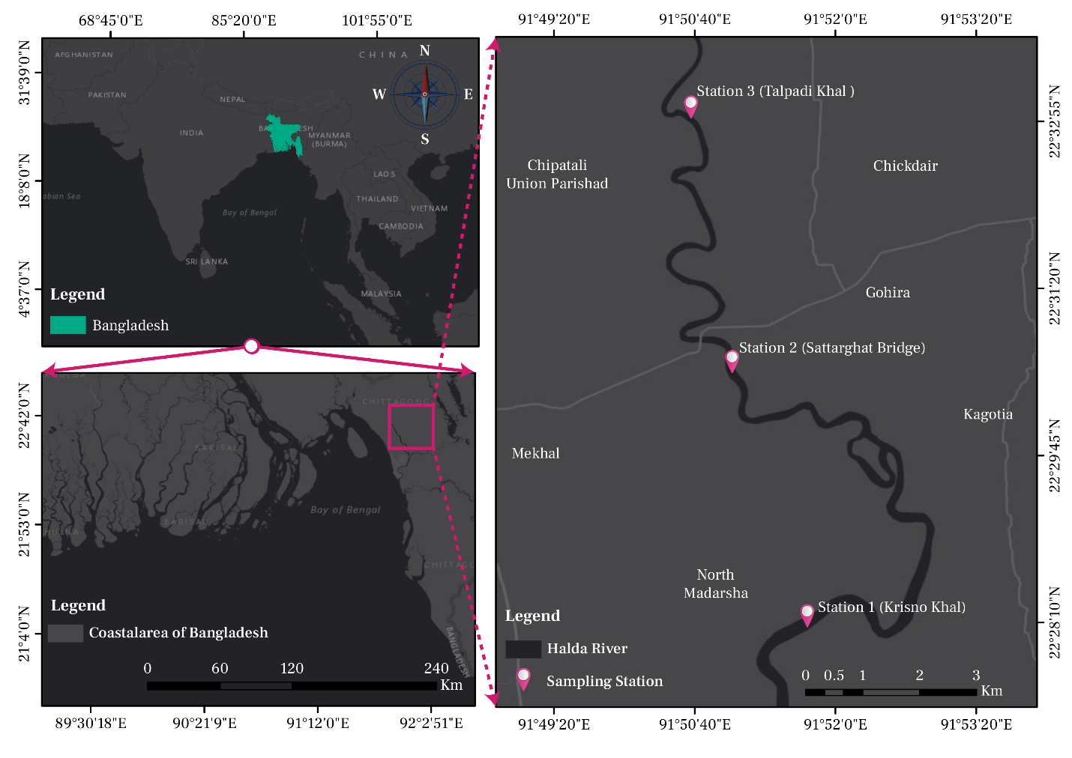

**Fig : Map showing the three sampling stations of the study**

**Literature Review**

Sharifetal (2017) studied the occurrence and distribution of zooplankton in the lower Meghna river and its Estuary with relation to physico-chemical parameters. They found about 37 major Zooplankton taxonomic groups of which 32 and 23 were recorded during monsoon and post-monsoon reasons. Salinity and pH were Significantly liable for the variations in Zooplankton structure.

Hena et al. (2016) studied on the seasonal distribution of zooplankton composition and abundance in a Sub-tropical mangrove and salt marsh estuary. They found copepod was the highest among zooplankton groups, and the abundance of copepod was influenced by rainfall, water temperature, and transparency.

Basher et al. (2015) studied on the seasonal variation of the zooplankton population in Kaptai lake, Bangladesh. In their finding, total zooplankton showed positive and negative correlations with water quality.

Hossain et al. (2015) managed to observe the species composition and abundance of zooplankton population in freshwater Noakhali district, Bangladesh. They found 14 gerera of zooplankton and temperature varied from 25-30°C , pH 60-90 and salinity 0 ppt

Rahaman and Hassain (2008) Carried out a study on the abundance of zooplankton of a culture and a nonculture pond of the Rajshahi University Campus. They found a total of I genera Of Zooplankton and Cyclops was most abundant in both ponds. Total zooplankton show positive relation with pH and alkalinity in both ponds.

Kabir and Naser (2008) conducted a study on the quantitative study of zooplankton in Chandbill baor of Meherpur district, Bangladesh. In this study zooplankton showed two distinct high peaks, one in February and in June.

Chowdhury et el. (2008) studied on the seasonal dynamics of plankton on relation to some environment factors in a beel ecosystem of Bangladesh in which a total of 47 genera of plankton was recorded.

Roy et al. (2010) studied on the diversity and Seasonal variation of Zooplankton in a brood pond of Khulna district, Bangladesh. They found copepod was the dominant order in the brood pond. Among various orders of zooplankton, the percentages of Copepoda, Rotifera, Cladocera, Ostracoda and crustacean in brood fish culture system were 55%, 81%, 9%, 2% and 1% respectively.

Zafar and Mohmood (1989) observer the distribution zooplankton communities in the Satkhira estuary.

Alam and Kabir (2003) work on the relationship between zooplankton abundance and physiochemical parameters in Sundarban ecosystem during monsoon. They found the relationship between zooplankton abundance and water quality parameters was varied from place to place depending upon the condition of the water body.

Islam (2007) investigation on the physio-chemical condition and occurrence of some zooplankton in a pond of Rajshahi University. It was found that the peak population was in April diurnal change of water temperature and occurrence were also studied.

Nahar et al. (2008) studied the Rotifera from of these pristine water ponds from south eastern Bangladesh.

Mojumder (2018) conducted a taxonomic study of zooplankton fauna in lower Halda River. He found a total of 3 mojar Zooplankton group and 42 species under 4 classes. Dominancy class Rotifer (36%) and Cladocera (28%).

Dery et al. (2003) a compress of zooplankton communication in saline lake water with variable anion composition the relationship between types of salts and zooplankton communicates is poorly understood. different zooplankton communities were observed among the two group.

Paturej (2015) studeied the effect of salinity levels on the structure of zooplankton communities. Zooplankton abundance and biodiversity are affected by salinity levels . Statistical analysis revealed a significant correlation between salinity levels and the number of species abundance and biomass of zooplankton but not affects the diversity of zooplankton communities

Mamun (2016) studied the abundance and abundance and composition of zooplankton in relation to ecological parameters in Kohelia channel Moheshkali, Cox’s Bazar, Bangladesh. He found the abundance of zooplankton varied between 240.20 individual/m3 to 111.40 individuals/m3 the monsoon and 140.74 to 44.56 individuals/m3 during post monsoon. Total zooplankton biomass showed both positive and negative correlation with ecological parameters.

Zaleha et al. (2006) Zooplankton in east coast Of peninsular Malaysia where temporal variation in zooplankton density and composition was not entirely attributed to the monsoon.

Hayat et al. (2020) studied on zooplankton diversity during sparing season in Chashma Lake, Pakistan. They found different species of Rotifers, Copepods and Cladocerans.

**Materials and Methodology**

**3.1: Sampling duration**

The Sampling was carried out during monsoon and post monsoon zooplankton and water Sample were collected from selected three points over the period at the time of 7.00- 11.50 am.

**Sampling design**

Sampling was done primarily by means of field observation. In the study only one type of sample was collected to determine abundance and distribution of zooplankton in three sits.

**3.2: Apparatus**

For sampling available apparatus were used such as

1. Plankton net
2. Plastic jar
3. Formalin
4. Ethanol
5. Reagent bottle
6. Petri dish
7. Slide
8. Cover slip
9. Fine brush

10. Needle

11. Fine Forceps

12. Markers

13. Camara

14. Light Microscope

15. GPS

**3.3: Sample Preservation**

The Collected sample were preserved in 5% formalin in the plastic jars immediately after collection and taken to the Lab of the Institute of Marine Science, University of Chittagong. For further study, samples were preserved in 70% alcohol.

**3.4: Identification**

Preserved samples brought under the microscope and identified with morph matric Characters according to Davis (1955), Das (1982), Zafar (1986), Allstrom (1940), Edmondsom (1959), Ahmed (1984), Elias (1983), Wilson (1959), Ahmed (1984), Elias (1983), Wilson (1959), Bhouiyan and Asmat (1992).

**3.5: Zooplankton Counting**

In each catch total number of individuals counted by complete counting. The Zooplankton concentration was calculated at individuals/m3. Where total volume of water (m3) filtered through the net was calculated by using the following Equation

Total volume of Water (m3) = ((FR-IR)) × coefficient) x

Where, FR = Final Reading, IR= Initial Reading, Coefficient = 0.3, = 3.1416

r = Radius of ring of used at Plankton net = 12cm

Abundance of zooplankton (Individuals/m3)= (Number of sp in each group/volume of water)

**Observation and Result**

**4.1: Environmental Parameters**

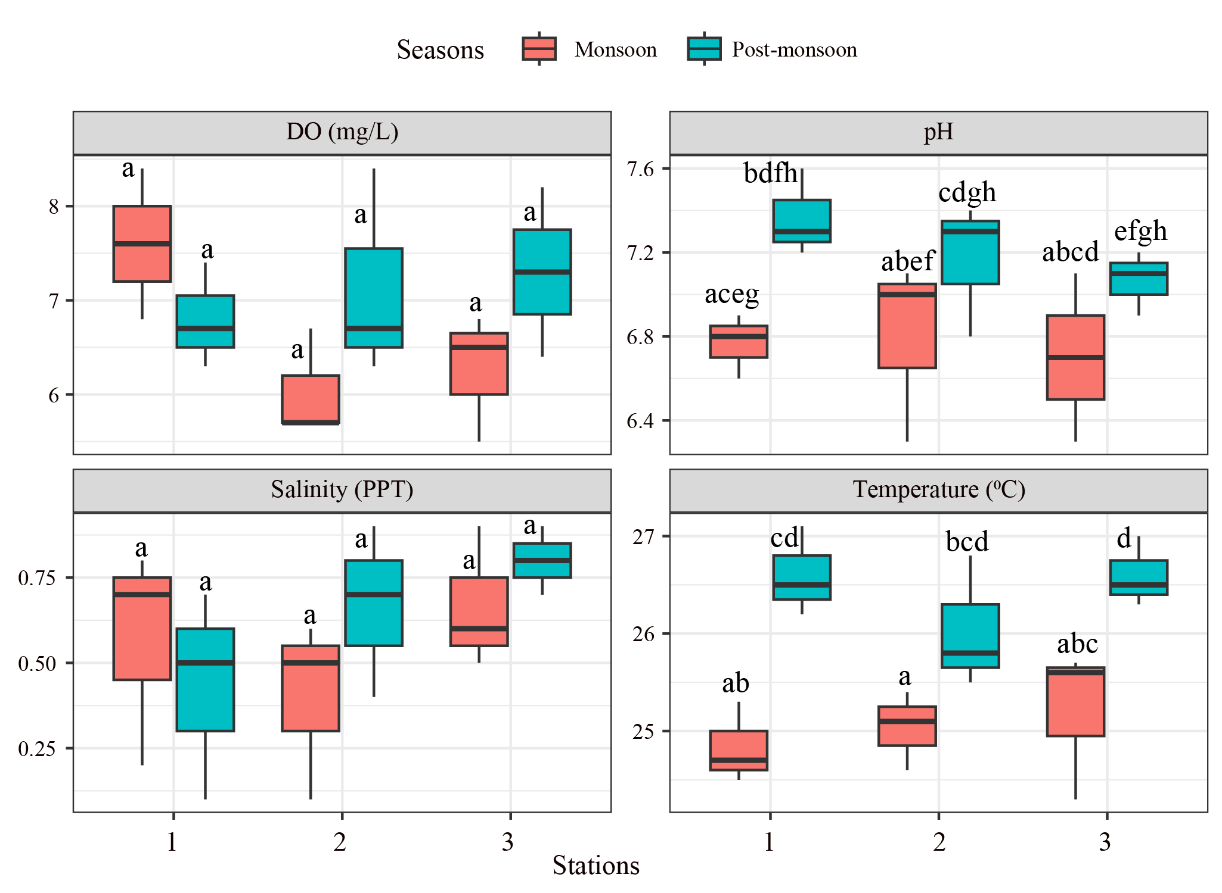

Figure 00: The temporal variation of water quality parameters. Different letters above the boxplot depicts significant diference (Two way ANOVA, P < 0.05) between two seasons and eight stations with ten observation each (n = 5).

**■ Water Temperature**

During monsoon the temperature ranges between 21⁰C to 28⁰C. Highest temperature was collected from station -3. During 2nd sampling in post monsoon temperature ranges between 25⁰C to 28⁰C. Highest temperature range was recorded in station-03 (Table 01).

**Table-1: Water Temperature variation at different sampling stations**

|  |  |  |
| --- | --- | --- |
| Stations | Monsoon (⁰C) | Post monsoon (⁰C) |
| Station 01 | 24.5 | 25 |
| Station 02 | 25 | 25.5 |
| Station 03 | 25.5 | 26.5 |

**■ Water PH**

Water pH was ranges between 6.8 to 7.2 during monsoon. Highest pH was recorded in station 03. In past monsoon PH was recorded between 7.0 to 7.3 highest value was found again at station 03 (Table 02).

**Table-2: Water pH variation at different sampling stations**

|  |  |  |
| --- | --- | --- |
| **Stations** | **Monsoon** | **Post monsoon** |
| Station-1 | 6.8 | 7.0 |
| Station-2 | 7.0 | 7.2 |
| Station-3 | 7.1 | 7.3 |

■**Water Salinity**

**Table-3: Water pH variation at different sampling stations**

|  |  |  |
| --- | --- | --- |
| **Stations** | **Monsoon (ppt)** | **Post-monsoon(ppt)** |
| Station-01 | 0.3 | 0.5 |
| Station-02 | 0.1 | 0.2 |
| Station-03 | 0.0 | 0.0 |

**4.2: Zooplankton Distribution and abundance**:

■ **Zooplankton Distribution**

Distribution Of different groups of zooplankton varied from one Station to another.

Primary data collected from three station of Halda during monsoon. The major group that dominated the findings are copepod, acetes, shrimp Larvae, crab larvae, mysid, lucifer, amphipod, sagittal. The minor number of daphnia, Fish larvae also found.

Total number of zooplankton varied from 2.41 ind/m3 to 62.6 ind/m3 in studied throughout the research period. Among the group copepod comprises the highest amount, accounting of total sample in station -01 but in station -03 shrimp larvae was dominate. Distribution patterns of zooplankton are given in table-04

**Table -04: Spatial and temporal distribution of zooplankton in Halda River**

|  |  |  |  |  |  |  |  |
| --- | --- | --- | --- | --- | --- | --- | --- |
| **Groups** |  | **Monsoon** | | | **Post Monsoon** | | |
|  | S1 | S2 | S3 | S1 | S2 | S3 |
| Mysid |  | + | + | + | + | + | + |
| Crab Larvae |  | - | + | + | + | + | + |
| Shrimp larvae |  | + | + | + | + | + | + |
| Acetes |  | + | + | + | + | + | + |
| Daphnia |  | + | + | + | + | + | + |
| Fish larvae |  | + | + | + | + | + | + |
| Sagitta |  | + | + | + | + | + | + |
| Copepod |  | + | + | + | + | + | + |
| lucifer |  | - | + | + | + | + | + |
| Amphipod |  | - | + | + | + | + | + |
| Unidentified |  | + | + | + | + | + | + |

**■ Abundance of Zooplankton at Stations**

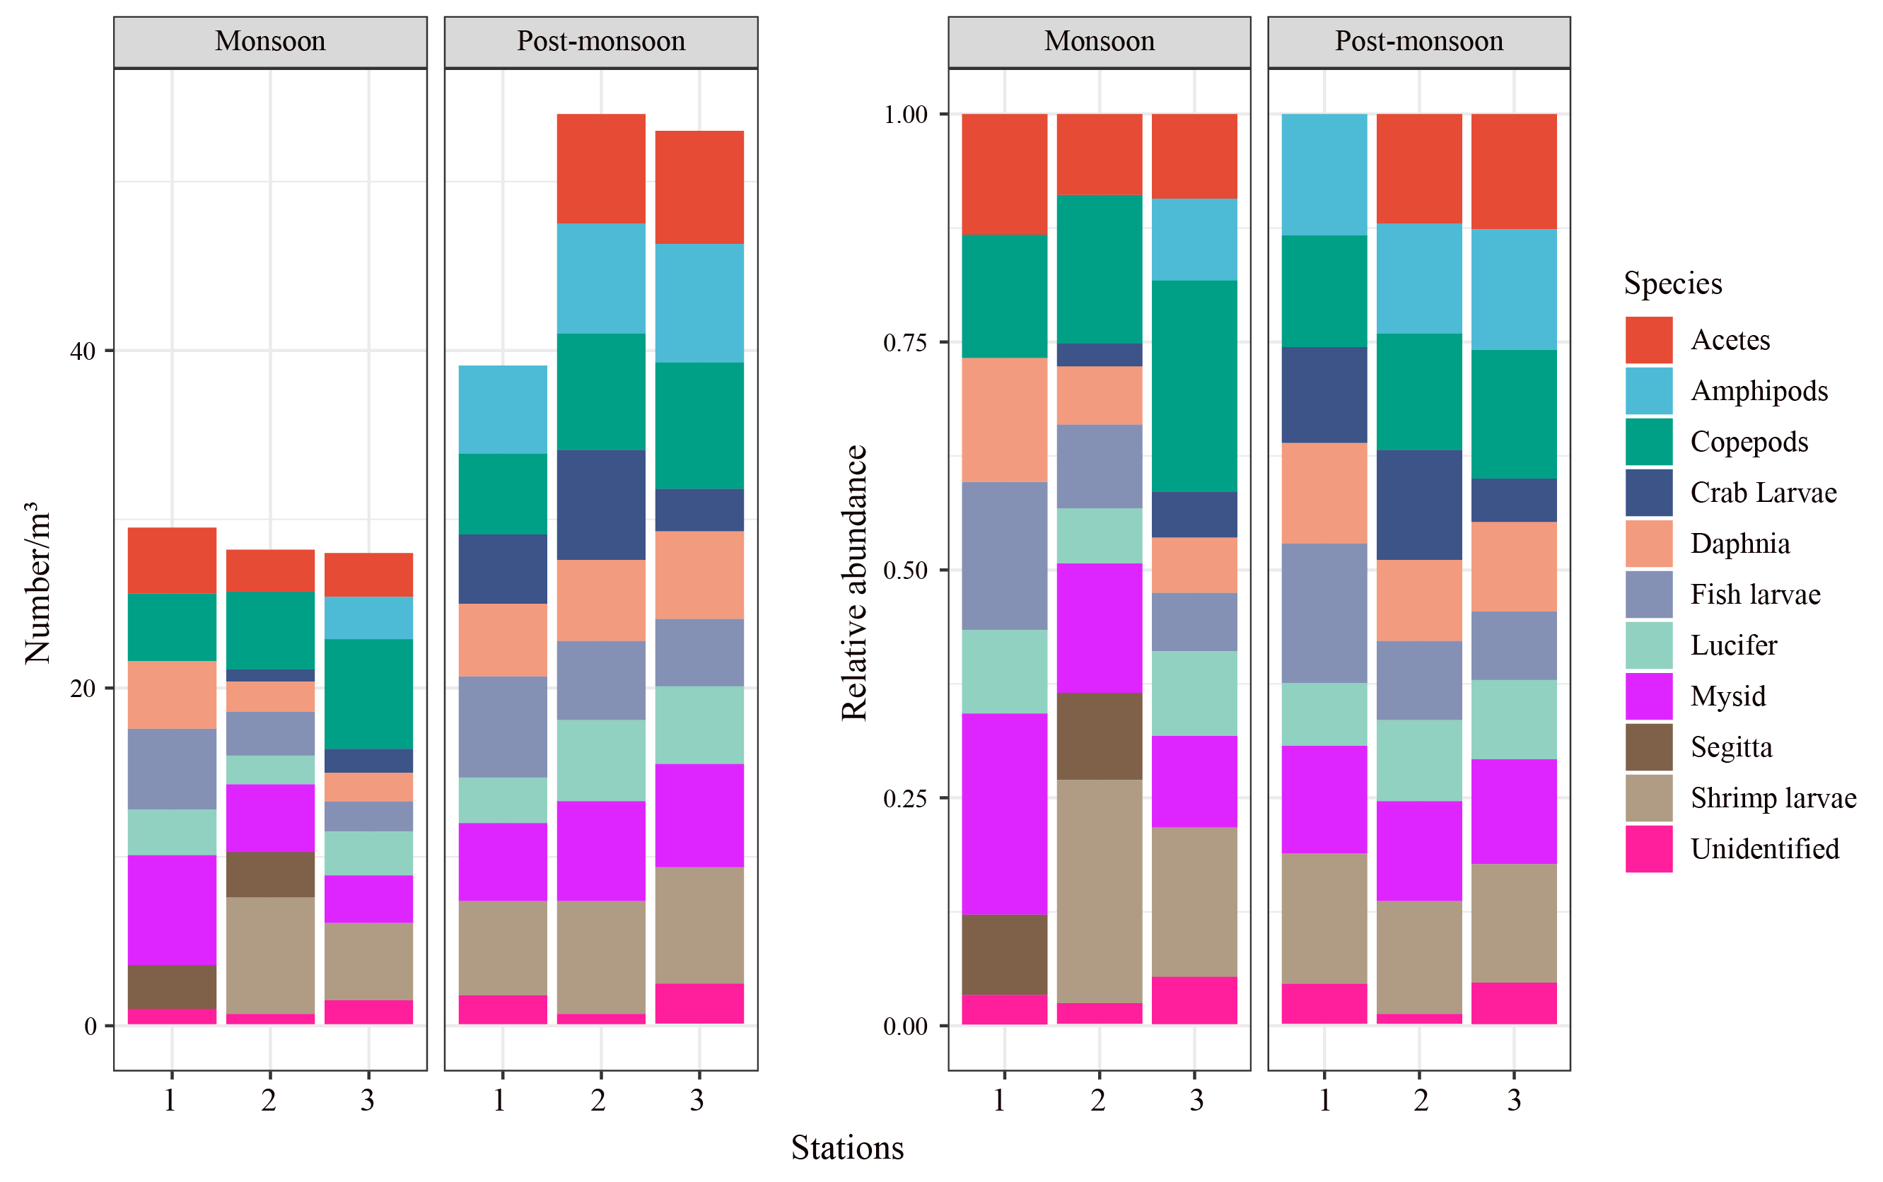

Figure00: Relative abundance and number of different zooplankton genus found at the eight stations (1-8) in two seasons (Monsoon and Post-monsoon).

**Table-05: Abundance of zooplankton in station -1 at monsoon period.**

|  |  |  |  |
| --- | --- | --- | --- |
| **TAXON** | **Ind/Haul** | **Ind/m3** | **%** |
| Fish Larvae | 23 | 4.8 | 19.34 |
| Copepod | 18 | 4 | 19.34 |
| Segitta | 11 | 2.6 | 9.24 |
| Daphnia | 17 | 4.0 | 14.28 |
| Acetes | 16 | 3.9 | 13.46 |
| Crab Larvae | 0 | 0 | 0 |
| Mysid | 29 | 6.5 | 24.37 |
| Unidentified | 5 | 1.0 | 4.21 |
| **Total** |  | **26.8** |  |

**Table-06: Abundance of zooplankton in station -2 during monsoon period**

|  |  |  |  |
| --- | --- | --- | --- |
| **TAXON** | **Ind/Haul** | **Ind/m3** | **%** |
| Fish Larvae | 13 | 2.6 | 9.49 |
| Copepod | 21 | 4.6 | 15.33 |
| Segitta | 14 | 2.7 | 10.22 |
| Daphnia | 9 | 1.8 | 6.57 |
| Acetes | 11 | 2.5 | 8.03 |
| Crab Larvae | 3 | 0.7 | 2.19 |
| Mysid | 18 | 4.0 | 13.19 |
| Strimp larvae | 38 | 6.9 | 27.74 |
| Lucifer | 7 | 1.7 | 5.11 |
| Unidentified | 3 | 0.7 | 2.19 |
| **Total** |  | **27.5** |  |

**Table-07: Abundance of Zooplankton in Station -3 during monsoon period**

|  |  |  |  |
| --- | --- | --- | --- |
| **TAXON** | **Ind/Haul** | **Ind/m3** | **%** |
| Fish Larvae | 8 | 1.8 | 6.0 |
| Copepod | 31 | 6.5 | 23.48 |
| amphipod | 12 | 2.5 | 9.09 |
| Daphnia | 7 | 1.7 | 5.30 |
| Acetes | 14 | 2.6 | 10.61 |
| Crab Larvae | 5 | 1.4 | 3.79 |
| Mysid | 16 | 2.8 | 12.12 |
| Strimp larvae | 21 | 4.6 | 15.91 |
| Lucifer | 12 | 2.6 | 9.09 |
| Unidentified | 6 | 1.5 | 6.82 |
| **Total** |  | **27.8** |  |

**Table 08: Abundance of Zooplankton in Station -1 during post monsoon period**

|  |  |  |  |
| --- | --- | --- | --- |
| **TAXON** | **Ind/Haul** | **Ind/m3** | **%** |
| Fish Larvae | 28 | 6 | 14.14 |
| Copepod | 22 | 4.8 | 11.11 |
| amphipod | 24 | 5.2 | 12.12 |
| Daphnia | 20 | 4.3 | 10.10 |
| Mysid | 21 | 4.6 | 10.6 |
| Strimp larvae | 26 | 5.6 | 13.13 |
| Crab Larvae | 17 | 4.1 | 8.58 |
| Fish Larvae | 14 | 2.7 | 7.00 |
| Lucifer | 18 | 2.7 | 9.00 |
| Unidentified | 8 | 1.8 | 4.00 |

**Table 09: Abundance of Zooplankton in Station -2 during Post-Monsoon**

|  |  |  |  |
| --- | --- | --- | --- |
| **TAXON** | **Ind/Haul** | **Ind/m3** | **%** |
| Copepod | 32 | 6.9 | 12.96 |
| amphipod | 30 | 6.5 | 12.15 |
| Acetes | 28 | 6.5 | 11.33 |
| Daphnia | 22 | 4.8 | 8.91 |
| Mysid | 27 | 5.9 | 10.93 |
| Strimp larvae | 30 | 6.7 | 12.15 |
| Crab Larvae | 28 | 6.5 | 11.33 |
| Fish Larvae | 26 | 4.7 | 10.53 |
| Unidentified | 3 | 0.7 | 1.21 |
| **Total** |  | **53.8** |  |

**Table 10: Abundance of Zooplankton in Station -3 during post monsoon period**

|  |  |  |  |
| --- | --- | --- | --- |
| **TAXON** | **Ind/Haul** | **Ind/m3** | **%** |
| Copepod | 54 | 7.5 | 19.64 |
| amphipod | 39 | 7.0 | 14.64 |
| Acetes | 31 | 6.7 | 11.27 |
| Lucifer | 21 | 4.6 | 7.64 |
| Fish Larvae | 18 | 4 | 7.64 |
| Crab Larvae | 11 | 2.5 | 4.00 |
| Shrimp Larvae | 37 | 6.9 | 13.45 |
| mysid | 28 | 6.1 | 10.18 |
| Daphnia | 25 | 5.2 | 9.09 |
| Unidentified | 11 | 2.5 | 4 |
| **Total** |  | **53** |  |

**Biodiversity Index**

■ The Shanon wiener index: the Shanon – wiener index (H) was used to summarize the information on the relative abundance of Zooplankton Species found within study area

H== -∑pixIn(PI) Here, Shanon diversity index: H

Number of individual Species = ni, Total number of Species =N

Where, Pi is the proportional abundance of the Species= (ni/N)

**Table -11: The Shanon wiener index**

|  |  |  |
| --- | --- | --- |
| **Stations** | **Monsoon** | **Post monsoon** |
| Station-1 | 2.509 | 2.47 |
| Station-2 | 2.421 | 2.46 |
| Station-3 | 2.464 | 2.51 |

**■ Pielou’s Evernnes Index**

Evenness Index, J = {H (s)/Hmax} Where , H(S) = Shanon diversity index

Hmax = L

**Table -12: Pielou’s Evernnes Index**

|  |  |  |
| --- | --- | --- |
| **Stations** | **Monsoon** | **Post monsoon** |
| Station-1 | 0.94 | 0.98 |
| Station-2 | 0.96 | 0.96 |
| Station -3 | 0.99 | 0.97 |

**■ Margaflef Richness Index**

Formula Of Margalef Richness Index is , d= (S-1)/logN

Where, S= total number Of Species, N= number Of Individual

**Table -13: Margaflef Richness Index**

|  |  |  |
| --- | --- | --- |
| **Stations** | **Monsoon** | **Post monsoon** |
| Station-1 | 1.99 | 1.99 |
| Station-2 | 2.4 | 1.87 |
| Station -3 | 2.1 | 1.79 |

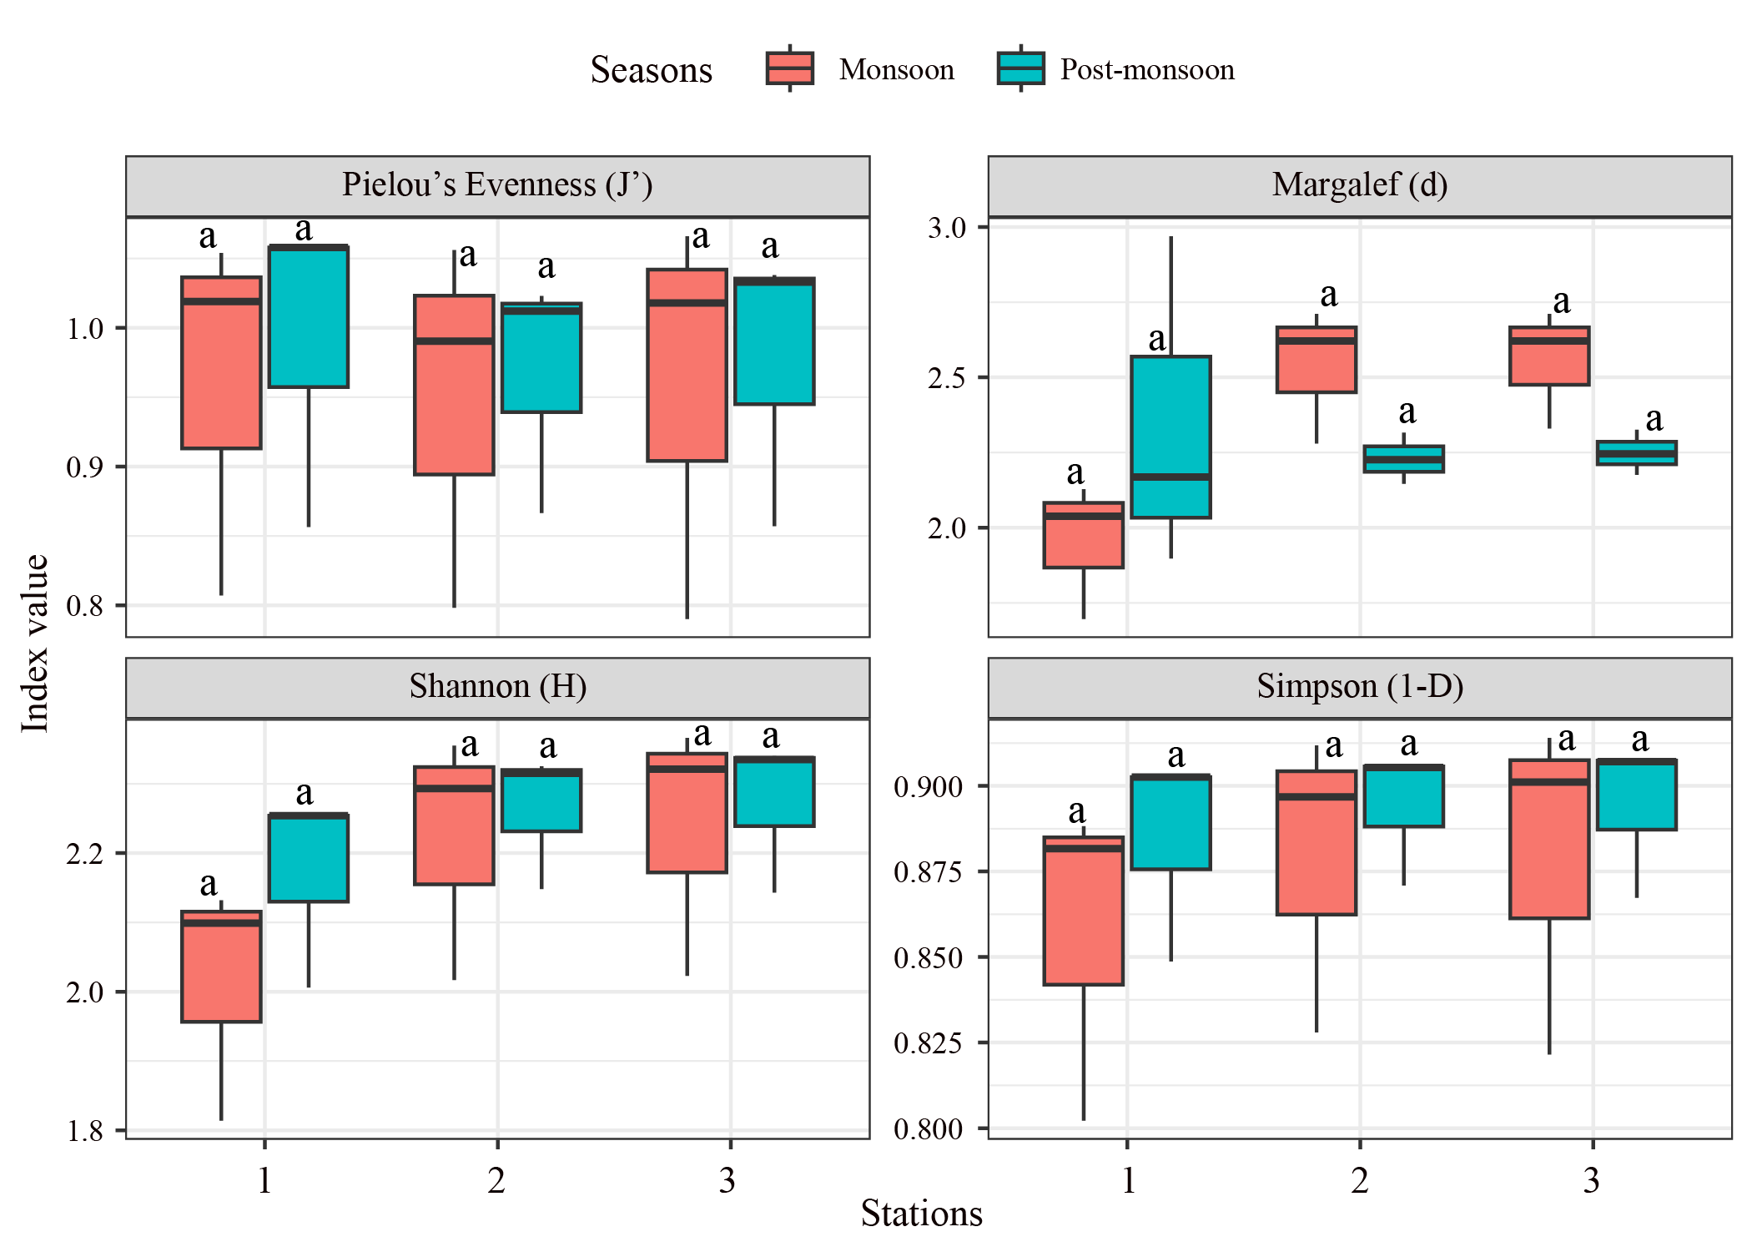

Figure 00: Boxplot showing the Diversity indexes (Pielou’s Evenness (J'), Margalef (d), Shannon (H), Simpson (1-D)) of zooplankton in two seasons at eight stations. Different letters above the boxplot depicts the significant difference (Two way ANOVA, P < 0.05) between two seasons and eight stations.

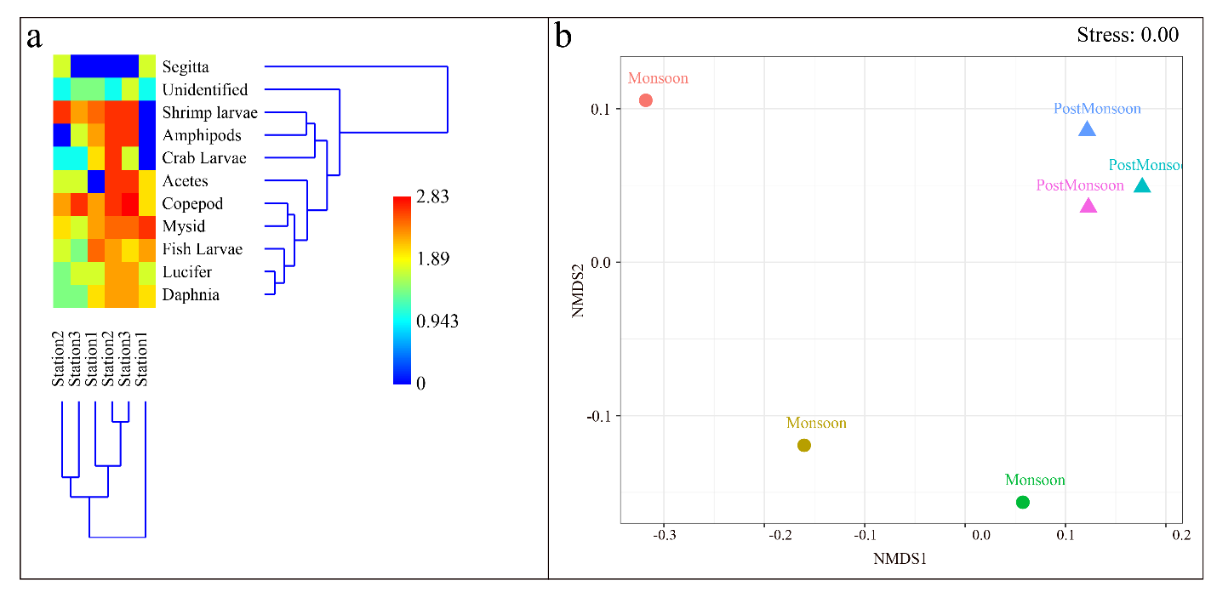

Figure 00: Two-way dendrogram plot showing similarity between sites and seasons (a); and non-parametric multidimensional scaling (nMDS) ordination of phytoplankton clustering on Bray-Curts similarities on square-root-transformed abundance data of the zooplankton communities among two seasons at eight stations (b).

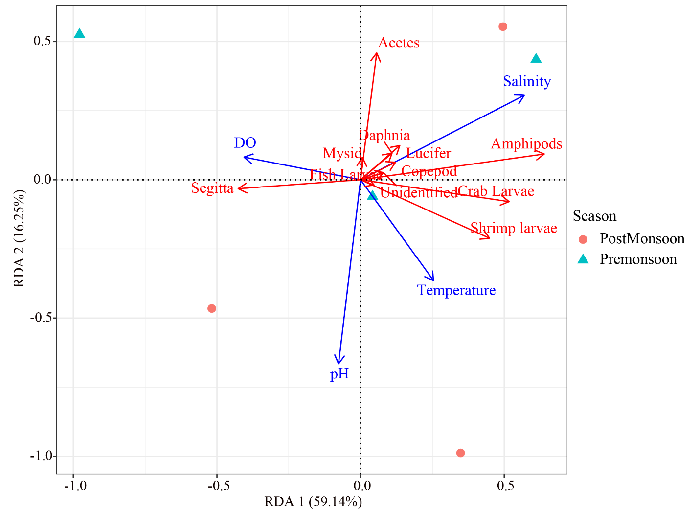

Figure 00: Relationship between environmental factors and zooplankton communities: a redundancy analysis of zooplankton dominant genus and the relation with water quality parameters, the vectors represent the most correlating water quality parameters (p <0.05).

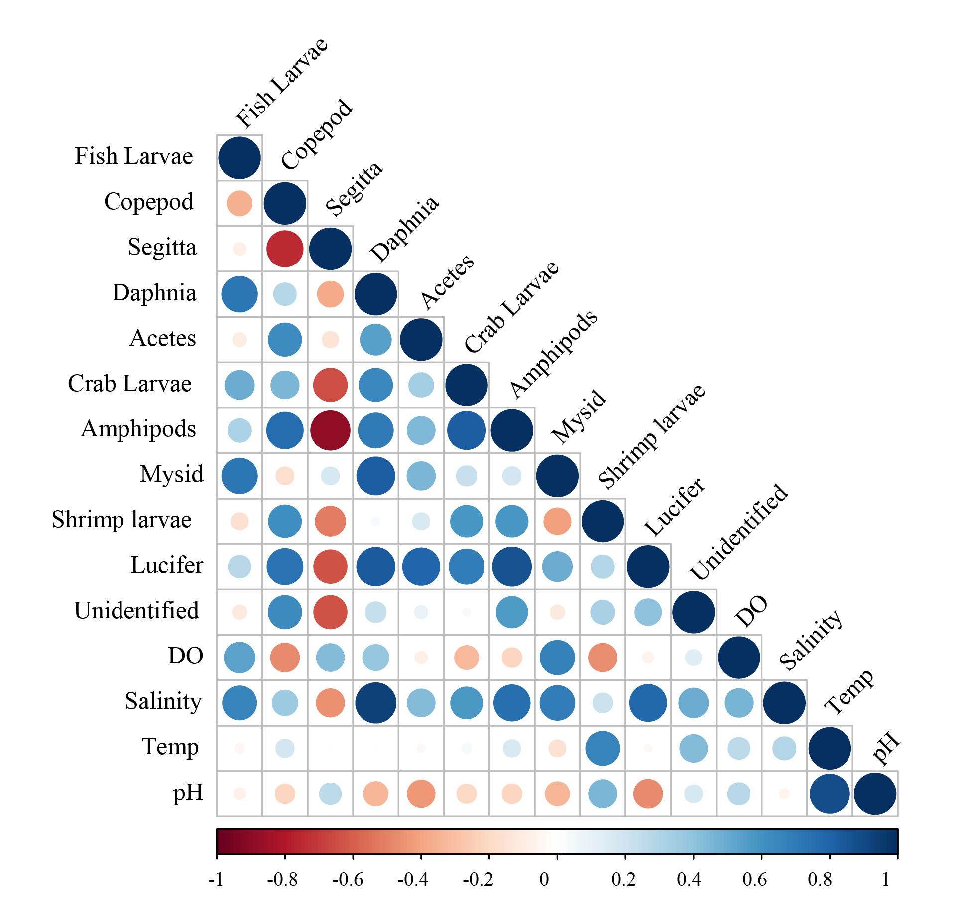

Figure 00: Relationship between environmental factors and communities: Correlations between zooplankton communities with environmental variables, color gradient corresponds to spearman correlation coefficients between environmental indicators.

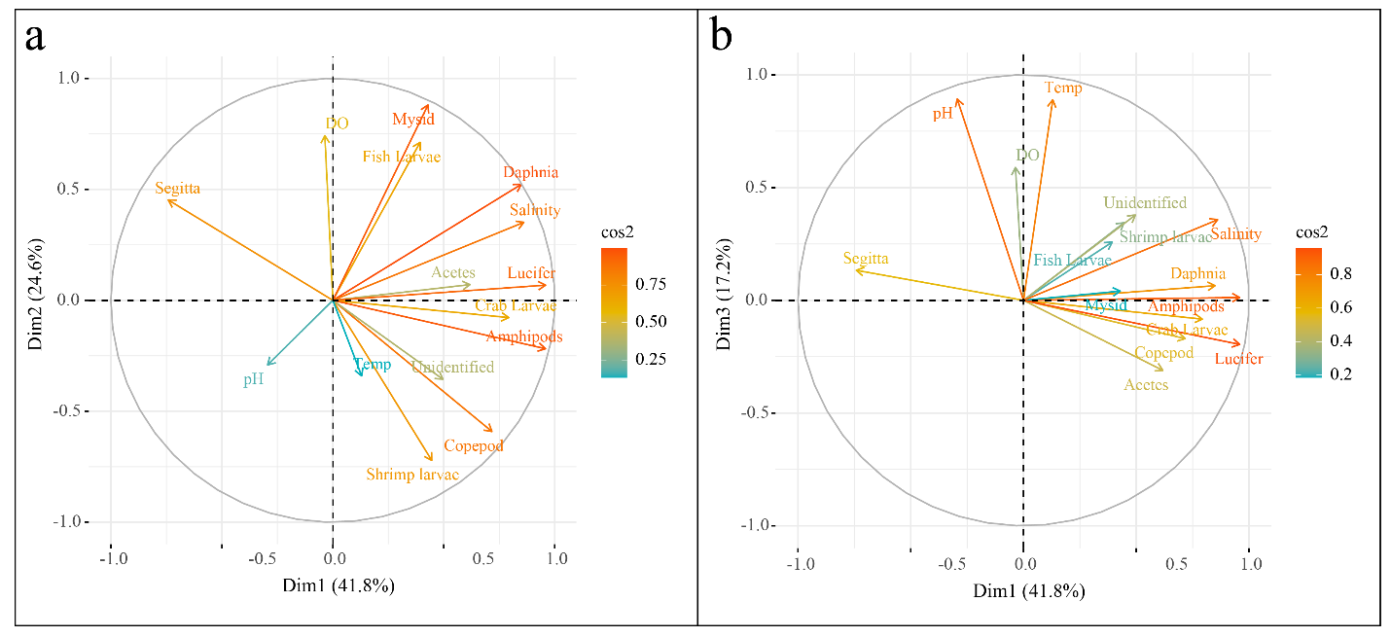

Figure 00: Biplot with correlation circle from principal component analysis (PCA) of water quality parameters and phytoplankton abundance data: axes 1-2 (a); axes 1-3 (b). The quality of the representation of the quantitative variables is indicated by the cos2 value. pH: hydrogen potential, Temperature (°C), salinity (ppt), DO: dissolved oxygen concentration (mg/L). The quality of the representation of the variables on the graph is indicated by the squared cosine of the variables (cos 2).

**Discussion**

Altogether 10 major Zooplankton groups were identified in the present study, namely Copepod, Acetes, Amphipod, Daphnia, Mysid, Shrimp Laevae, Crab Larvae, Sagitta fish Larvae, Lucifer and Unidentified from the Halda river. Aslam and Aziz (1975) also identified 18 genera of Bangladesh. Das et al. (1982) identification 21 Group of Zooplankton from the continental shelf of the Bay of Bengal. A study by Zafar (1986) was recorded 14 Groups of zooplankton from the Coxali river estuary.

Sharif (2001) identified 23 majar taxa of zooplankton from the Meghna river estuary while Goswari (1985) identified 24 Zooplankton taxa from the coastal water of Goa.

Total number of zooplankton varied from 10.2 ind/m3 to 9.3 ind/m3 in studied are throughout the research period. Highest found group was Copepod in station-3 at post monsoon accounting 19.2% total in individual.

Sharnon Diversity

In Shanon diversity index (H) the highest value was 2.509 recorded at station -1 during Monsoon and the lowest value was 2.421 recorded at Station-2 during monsoon. As the value was higher in station -1. It was well diverse than others station.

In post monsoon the highest value was 2.51 recorded at station -3 and lowest value was 2.46, as diverse than others station.

Pielou's Evenness Index

The evenness (J) was ranges between 0.94 to 0.99 during monsoon and 0.94 to 0.99 during monsoon and 0.98 to 0.99 during Post monsoon in the study area. The highest value was found in station -3 during Post monsoon

Margalef Richness Index

The richness (d) was found in range of 1.9 to 2.4 at monsoon and 1.7 to 1.99 during monsoon.

Dissolved Oxygen is one of the essential factors for aquatic organism such as zooplankton. The highest Do was recorded S.H mg/L and lowest was recorded 4.285 mg/L. Rahman (1997) reported that do 4.63 mg/L Mohakhali Channel during October.

pH is one of the major factor for aquatic environment. The highest value was found 7.7 to 5.5. Fatema (2017) found pH in the range of 7.61 to 8.79 in Buriganga river.

The highest transparency of water was highest recorded 32 cm and lowest was 26.5 cm. Haque (1983) recorded 205 cm water transparency in march in Pagla river and 46 cm in May.

Water temperature is very important for aquatic organism. During study water temperature ranged from 24°C to 29°C. Haque (1983) observed the temperature Of Matamuhuri estuary to be 28°C during October.

**Limitation**

It was not possible to collect samples not more than two times for lacking of time and unfavorable condition due to COVID 19.

**Conclusion**

In the present study around 10 groups of Zooplankton communities and some unidentified Species were identified in the aquatic environment of Halda River. Copepod was the dominated group considering the abundance. The values of Diversity index showed more fluctuation within season rather than station as it depends on different types of Hydrological factors in the environment.

**Recommendation**  
The present study was the baseline work in the Halda River, Chittagong. 10 species zooplankton were identified which play a vital role in river ecosystem. Further extensive research are needed for the resource conservation of both the fauna and flora of the Halda River.

**References**

Abu Hena M. K. and Khan, M. A. A. 2009. Coastal and estuarine resources of

Bangladesh: management and conservation issues. Maejo Int. J. Sci. Technol.

3(02), 313-342.

Abu Hena, M. K. "Composition of cephalopods in the Moheskhali channel, Cox's Bazar",

Research Report, Chittagong University, Bangladesh, 2006.

Afrin, R. 2006. Study on diurnal and tidal variation of zooplankton in- the eastern coast

of St. Martin's Island. B.Sc. (Honors), Term paper. Institute of Marine Sciences,

University of Chittagong. Bangladesh. 53pp.

Ahmed, A. T. A. 1990.Studies on the identity and abundance of molluscan fauna of the

Bay of Bengal.Bangladesh Agricultural Research Council contract research project.

Final report. 118 pp.

Ali, M. "Zooplankton diversity of salt marsh habitat in the Bakkhali river estuary,

Cox'Bazar, Bangladesh", 4th Year Project Paper, 2006, Institute of Marine

Sciences and Fisheries (IMSF), University of Chittagong.

Belal. M.H. 2001. A review of marine holoplankton of Bangladesh .coastal waters. (Term

paper). 4th year. B.Sc. Hons. Inst. Mar. Sci., University of Chittagong. 50-54pp.

Belal, M. H. 2003. Macrobenthos of the Meghna river Esturine bed secial reference to

polychaete faunal biodiversity. M.Sc (Thesis) IMSF, University of

chittagong.91pp.

Belaluzzaman, A. M. 1995.Ecology of the Intertidal Macrobenthic Fauna in Cox's Bazar

Coastal Area, Bangladesh. M. Sc. Thesis. Institute of Marine Sciences and

Fisheries, University of Chittagong.

Chattopadhyay C and Barik A, 2009. The Composition and Diversity of Net Zooplankton

Species in a Tropical Freshwater Lake. International Journal of Lakes and Rivers,

2 (1):21-30.

Clarke, K. R. and Warwick, R. M. 2006. Change in Marine Communities: An Approach to Statistical Analysis and Interpretation (2nd edn). PRIMER-E: Plymouth. 176 pp.

Conway, D. V. P., R. G. White, J. Hugues-Dit-Cile, C. P. Gallienne and D. B. Robins.

2003. Guid to the coastal and surface zooplankton of the south-western Indian

ocean. Marine Biological Association of the United Kingdom Occasional

Publication. 322 p.

Conway, D.V.P. (2012). Marine Zooplankton of southern Britain. Part 1: Radiolaria,

Heliozoa, Foraminifera, Ciliophora, Cnidaria, Ctenophora, Platyhelminthes,

Nemertea, Rotifera and Mollusca. A.W.G. John (ed.). Occasional Publications.

Marine Biological Association of the United Kingdom, No. 25, Plymouth, United

Kingdom, 138 pp.

Ahsan and Others 2012.Plankton Composition, Abundance and Diversity in

Hilsa(Tenualosa ilisha) Migratory Rivers of Bangladeshduring spawning season.

Dhaka University Journal of Biological Science21(2): 177‐189.

Elias, S. 1983. Abundance of Zooplankton of the Matamuhuri River Estuary with special

referance to shrimp and larvae., Postgraduate dissertation. IMSF, Uni. Ctg. 172 pp.

FAO (Food and Agricultural Organization), 1984. Integrated development of the

Sunderbans, Bangladesh", Fisheries integrated development in the Sundarbans,

based on the work of H. R. Rabanal, Technical Concept Paper/Bangladesh/2309.

Fauvel, P. 1953. The fauna of British India, including Ceylon and Burma, Annelida,

Polychaeta, The Indian Press Ltd. 505 pp.

Ferdous Z and Muktadir AKM, 2009. Potentiality of Zooplankton as

Bioindicator.American Journal of Applied Science, 6 (10):1815-1819.

Glasby, C. 1999.The Namanereidinae (Polychaeta: Nereidae). Part1. Taxonomy and

phylogeny. Records of the Australian Museum, Supplement, 25:1-129.

Habiba, U. 2001. Study on Post-monsoon distribution of some zooplankton of the

Buriganga river, Dhaka, Bangladesh. Term paper. 4th year, B.Sc.(Hons.). Inst. Mar.

Sci., University of Chittagong.

Harkantra, S. N. and Rodrigues, N. R. 2004. Environmental influences on the species

diversity, biomass and population density of soft bottom macrofauna in the

estuarine system of Goa, west coast of India., Indian Jornal of Marine Science, Vol.

33, 187-193pp.

Homyra, N. E. S. and Naz, S. 2005. Limnology of an artificial lake of Rajshahi,

Bangladesh of Journal Biological Science,13: 89-95.

Islam ABMW, Manira MS, Rahman MM, Zaman M 2007. Zooplankton of two Shrimp

Farms at Khulna, Bangladesh. South Asian Journal of Agriculture, 2(1&2):117–

122

Islam MN, Khan TA, Bhuiyan AS 2000. Ecology and seasonal abundance of some

Zooplankton of a pond in Rajshahi. Univ J Zoo, Rajshahi University 19:25–32

Islam, M. M. R. 1981. Seasonal variation of the phytoplankton of lotic (The Karnafuli

River estuary) and lentic water (Foy's Lake) environment., Postgraduate

dissertation. IMSF, Uni. Ctg. 72 pp.

Islam, M. S. 1982. Zooplankton communities of the Karnafuli River estuary during

Northeast monsoon with special reference to Chaetognaths., IMSF, Uni. Ctg. 61

pp.

Islam, M. S. 2012.Ecological aspects of the benthic macrofauna of satlmarsh of Fauzderhat

Chittagong coast, Bangladesh. Ph.D. Thesis.

Kolhe BG, SP Zambare, SB Andhale and MS Rane, 2013.An Estimation of Plankton

Population of Godawari River with Reference to Pollution.Biosci. Disc.,4(1):117-

120.

Kotpal, R. L. 1998.Zoology Phylum (Annelida, Mollusca, Arthropoda, Minor Phyla),

Rastogi Publications, Meerut, India.

Mahmood, N. 1990. A Study on immigration of commertially important penaeid shrimp

post-larvae in the esturine area of Chakaria, Cox's Bazar, Bangladesh., Ph. D.

Thesis. Dept. Zool., Uni. Raj. 133 pp.

Mamun, M. 2001. Study on Meroplankton of the coastal waters of Bangladesh, a review

work. Term paper. 4th year, B.Sc. (Hons.).Inst. Mar. Sci., University of Chittagong.

22pp.

Manjare S. A., Vhanalankar S. A. and Muley D. V. 2010. Water quality assessment of

Vadgaon Tank of Kolhapur (Maharashtra), with special reference to

zooplankton.International Journal of Advanced Biotechnology and Research 1(2)

91-95.

Martin, J. W. and G. E. Davis. 2001. An Update Classification of the Recent Crustacea.

Science Series No. 39, Natural History Museum of Los Angeles County. p. 58-75.

Masson , P,. Okogwu, O. I., 2001. Seasonal variations of species composition and

abundance of Zooplankton in Ehoma Lake, a floodplain lake in Nigeria.Rev. Biol.

Trop. Vol. 58 (1): 171-182.

Melad H. 2011.Marine Zooplankton Practical Guide for the Northwestern Arabian Gulf

Volume 1.Published in Kuwait in 2011 by Kuwait Institute for Scientific Research,

P.O. Box 24885, 13109 Safat, Kuwait.

Mohi, S. A. 1977. Distribution of ichthyoplankton in the Karnafuli River estuary in

relation to salinity., Postgraduate dissertation. IMSF, Uni. Ctg. 53 pp.

Mulyadi, M. D. 2002. The calanoid copepods family Pontellidae from Indonesian waters,

with notes on its species-groups. Treubia. 32(2):1-167.

Mulyadi, M. D. 2004.Calanoid Copepods in Indonesian Waters.Research Center for

Biology, Indonesia institute of Sciencs Bogor, Indonesia. 195 p.

Muxagata, E. & Williams, J.A. 2004. The mesozooplankton of the Solent-Southampton

water system: A photographic guide. Southampton Oceanographic Centre Internal

Document,No.97,103pp.Unpublishedmanuscript.

http://eprints.soton.ac.uk/9690/01/Zooplanktonguide.pdf.

Narendran, T. C. 2006.An Introduction to Taxonomy. Published by the Director, Zool.

Surv. India, Kolkata. 80pp.

Nargis, A. 2005. Study on occurrence and abundance of zooplankton groups in the flood

plain river of pagla, Bangladesh M.Sc. Thesis Inst. Mar. Sci., University of

Chittagong. 18pp.

Nixon, S.W., Oviatt, C.A., Frithsen, J. & Sullivan, B. 1986.Nutrients and the productivity of estuarine and coastal marine ecosystems.Journal of the Limnological Society of southern Africa 12, 43-71.

Rahman, M. M. 2008. Temporal distribution of zooplankton abundance in some selected

pond of Chittagong University Campus with special reference to environmental

parameters. IMSF, University of Chittagong.

Ramchandra TV and Solanki M, 2007. Ecological Assessement of Lentic Water Bodies of Bangalore.Envis Technical Report: 25. Indian Institute of Science, Bangalore.

Reddy VK, Prasad KL, Swamy M and Reddy R (2009).Physicochemical properties of

Pakhal Lake of Warangal district Andhra Pradesh, India. Journal of Aquatic

Biology 24(1) 77-80.

Shanks, A. (ed.) 2001. An identification guide to the larval marine invertebrates of the

Pacific northwest. Corvallis, Oregon State University Press, 314 pp.

Sharif. A.S.M. 2001. A comparative study on Plankton and Benthos of the Meghna river

estuary during monsoon and post monsoon. M.Sc. Thesis (Unpublished). Institute

of Marine Sciences, University of Chittagong. Bangladesh. 46-50pp'.

Sousa W, Jose L, Attayde, Elinez Dasilva Rocha and Eneida Maria Eskinazi-Santanna,

2008. The response of zooplankton assemblages to variations in the water quality

of four man-made lakes in semi-arid northeastern Brazil.J.Planktron Research,

30(6):699- 708.

Staffan, D. H. 1994. An environmental assesment of the Bay of Bengal region,

BOBP/REP/67. 77-129 pp.

Veronica Fernandes and Ramaiah N.2009.Mesozooplankton community in the Bay of

Bengal (India): spatial variability during the summer monsoon. Aquat. Ecol.,

vol.43 (4): 951-963

Ward, D., Holmes, N. and José P. 1995. The New Rivers and Wildlife Handbook.

Bedfordshire: RSPB, NRA, The Wildlife Trusts. 426 p.

Wikipedia. Available Source: http://en.wikipedia.org/wiki/Zooplankton. July 14, 2008.

Wutticharoenmongkol, N. and L. Wongrat, L. 2004. Diversity and abundance of

planktonic hydrozoans, class hydrozoa in the upper Gulf of Thailand.J. Science

Res. (Section T), 3(1):27-44. (In Thai, English abstract)

Young, C.M., Sewell, M.A. & Rice, M.E. (eds.) 2002.Atlas of marine Invertebrate larvae.

San Diego, CA, Academic Press, 626 pp.

Yuan, X. Z. 2001.Ecology study on the zoobenthic community in the wetland of the

estuarine tidal flat.PhD thesis, East China Normal University, Shanghai. 195p.

Zafar M. and N. Mahmood 1989. Studies on the distribution of zooplankton communities

in the Satkhira estuarine system", Chittagong Uni. Studies Sci., 13, 115- 122.

Zafar M. 2000.Study on Sergestid shrimp Acetes in the vicinity of Mathamuhuri river

confluence, Bangladesh, Ph D. Thesis, 2000, University of Chittagong,

Bangladesh.

Zafar, M. 1986. Study on Zooplankton of Satkhira in the vicinity of aquaculture farms

with special reference to Penaeid post larvae, M. Sc. Thesis, IMSF, Uni. Ctg. 238

pp.

Zafar, M. and Mahmood, N. 1989. Astudy on the distribution of zooplankton communities in the esturine system. Ctg. Uni. , Pt. II(Sc.) 13(I): 115-122 p

Kabir, A.K.M.N. and Naser, M.N. 2008. Qulitative and quantitative study of Zooplankton in Baor of Meherpur district, Bangladesh. Bangladesh J. Zool., 36(1): 69-75.

Kabir, M.H., Kibria, M.M., Jashimuddin, M. and M.M. Hossain. 2013. Economic Valuation of Tangible Resources from Halda–The Carp Spawning Unique River Located at Southern Part of Bangladesh. International Journal of Water Research.

Kabir, M.H., Kibria, M.M.,Russell, L.a. and Hossain, M.M.2014. Engineering activities and their mismanagement at Halda: a unique tidal river for natural spawning of Major Indian Carps. International Journal of Surface and Groundwater Management. 1(1): 59-66.

Kibria, M.M., Farid, I. and Ali, M. 2009. Halda Restoration Project: Peoples Expectation and Reality, A Review Report Based on the Peoples Opinion of the Project Area (In Bangla). Chittagong: Chattagram Nagorik Oddogh & Actionaid Bangladesh. 67p.

Kibria, M.M.2016. Impact assessment on upstream water withdrawal to conserve natural breeding habitat of major carps in the River Halda ( Biological Assessment). Ministry of fisheries and Livestock, Bangladesh Fisheries Research Institute. 5: 1-46.

Kumar, N.J.I., Yamini, V. and Kumar, R.N. 2011. Spatial analysis of composition and species interactions with temporal variation of zooplankton community of shallow tropical lake: thol Bird Sanctuary, India. Universal journal of Environmental Research and Technology., 1(2): 151-159

Rahi, M. L., Mahfuj, S. E., Islam, S. S., Islam, S. S., & Sabbir, W. (2015). Assessment of the abundance and species composition of phytoplankton of Moiur river, Khulna. Journal of Bio-Science, 21, 27–34. https://doi.org/10.3329/jbs.v21i0.22516

Ronald, W. R. P., & Azadi, M. A. (1987). Ecological studies on the planktonic organisms of the Halda River, Chittagong, Bangladesh. Bangladesh Journal of Zoology, 15(2), 109-123.

Roy, U., Shaha, B. K., Mazhabuddin, K., Haque, M. F., & Sarower, M. G. (2010). Study on the diversity and seasonal variation of zooplankton in a brood pond, Bangladesh, Marine. Res. Aqua., 1(1), 30-37.

Sarwar, M. I., Majumder, A. K., & Islam, M. N. (2010). Water quality parameters: a case study of Karnafully River Chittagong, Bangladesh. Bangladesh J. Sci. Ind. Res., 45(2), 177-181. <https://doi.org/10.3329/bjsir.v45i2.5722>

Shil, J., Ghosh, A. K., & Rahaman, S. B. (2013). Abundance and diversity of Zooplankton in semi intensive prawn (Macrobrachium rosenbergii) farm. SpringerPlus, 2, 183. [https://doi.org/10.1186/2193-1801-2- 183](https://doi.org/10.1186/2193-1801-2-%20183)

Thakur, R. K., Jindal, R., Singh, U. B., & Ahluwalia, A. S. (2013). Plankton diversity and water quality assessment of three freshwater lakes of Mandi (Himachal Pradesh, India) with special reference to planktonic indicators. Environmental Monitoring and Assessment, 185, 8355–8373. <https://doi.org/10.1007/s10661-013-3178-3>

Uddin, M. N., Alam, M. S., Mobin, M. N., & Miah, M. A. (2014). An assessment of the river water quality parameters: a case of Jamuna River. J. Environ. Sci. & Natural resources, 7(1), 249-256

Vashista, B. B. (2005). Botany for Degree students (part- 1) Algae, S. Ramnagar, New Delhi: Chand & Company Ltd. Vugteveen, P., Leuven, R. S. E. W., Huijbregts, M. A. J., & Lenders, H. J. R. (2006). Redefinition and elaboration of river ecosystem health: perspective for river management. Hydrobiologia, 565, 289–308. <https://doi.org/10.1007/s10750-005-1920-8>

Khanam, M. R. M., Naser, M. N., & Ali, S. (2014). Population dynamics of planktonic rotifers in the southern coastal area of Bangladesh. International Journal of Natural and Social Sciences, 1(2), 53-60. Retrieved from http://ijnss.org/wp-content/uploads/2014/11/IJNSS-V1I2-08-pp-53-60.pdf.

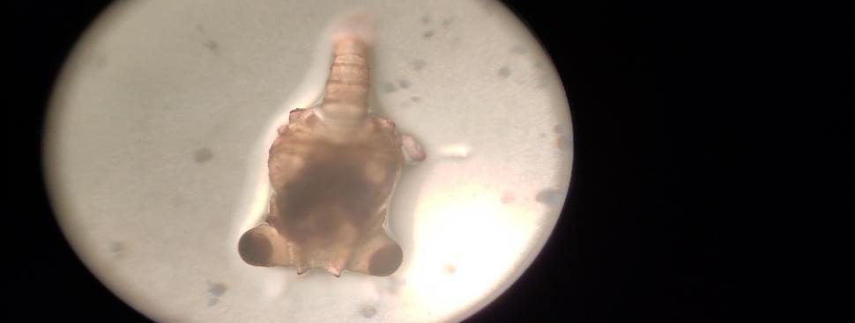**Mobile Picture** :

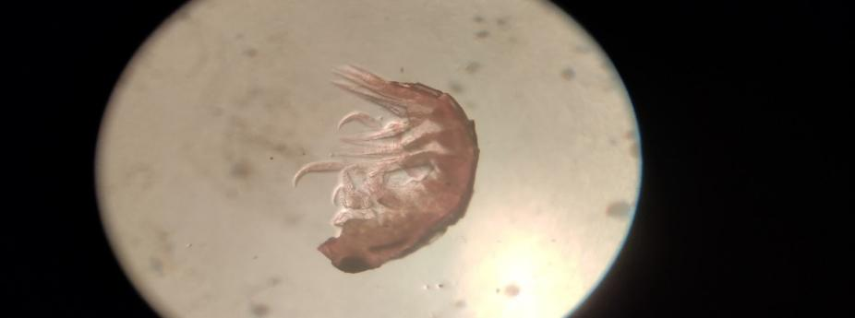

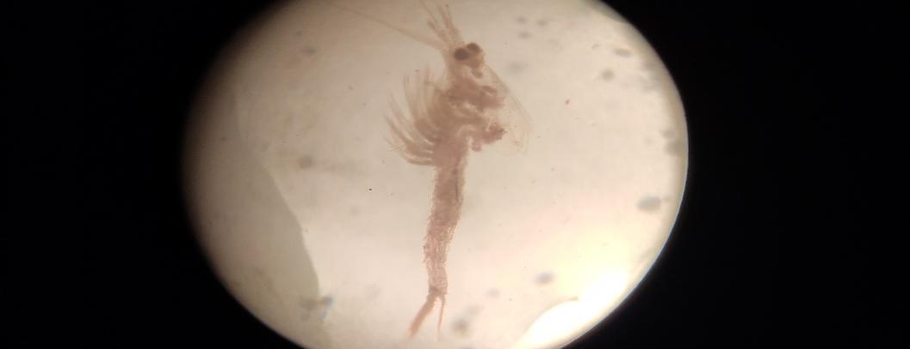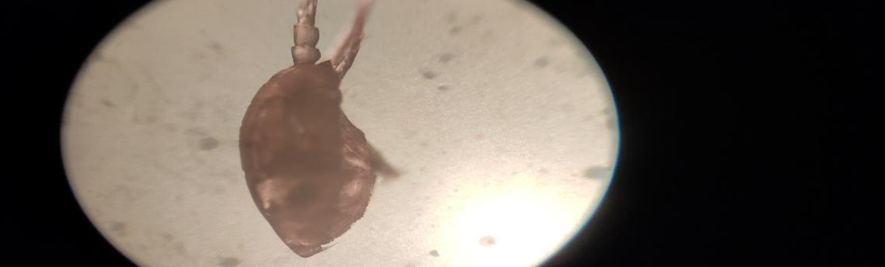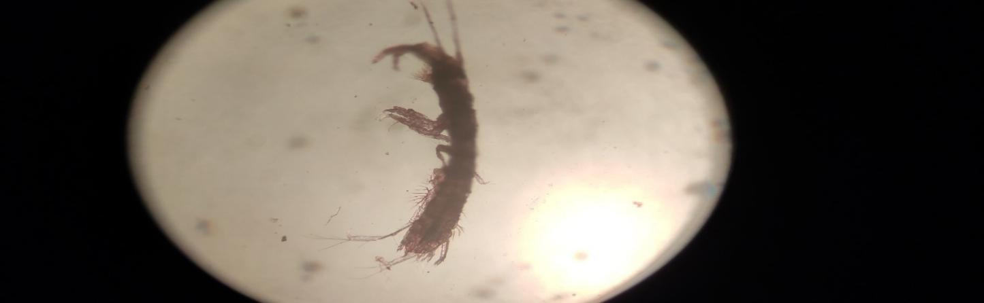

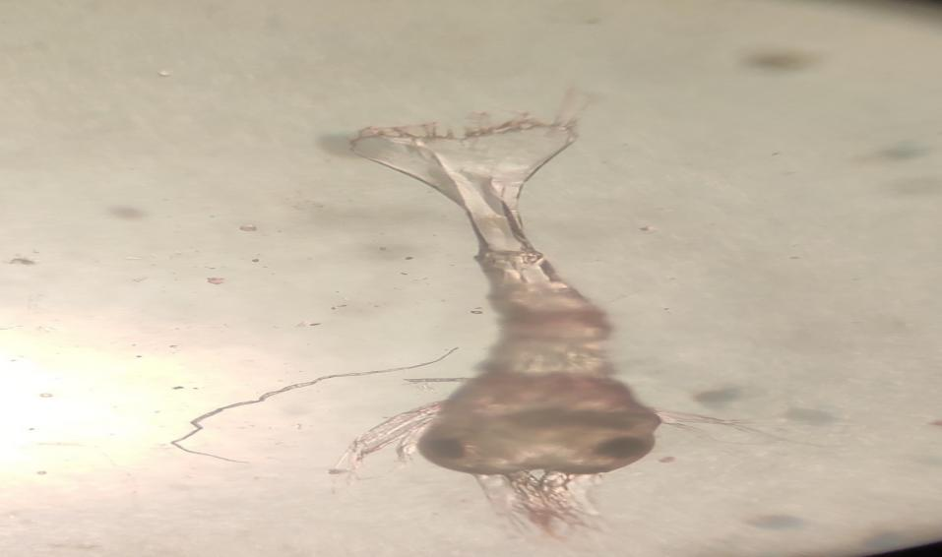

**Fig: Zooplankton species**

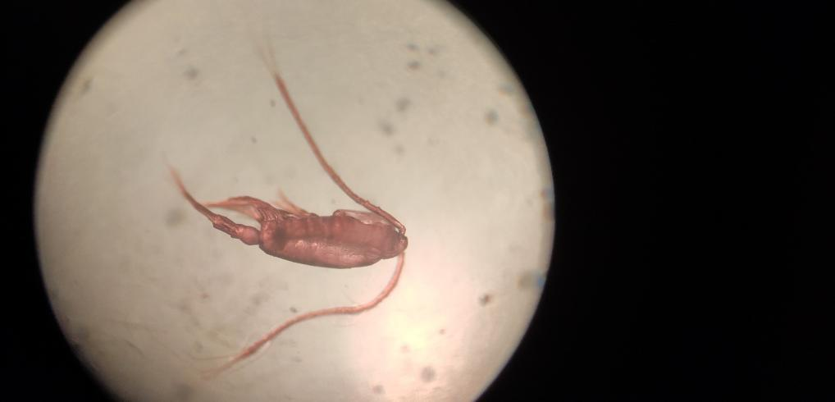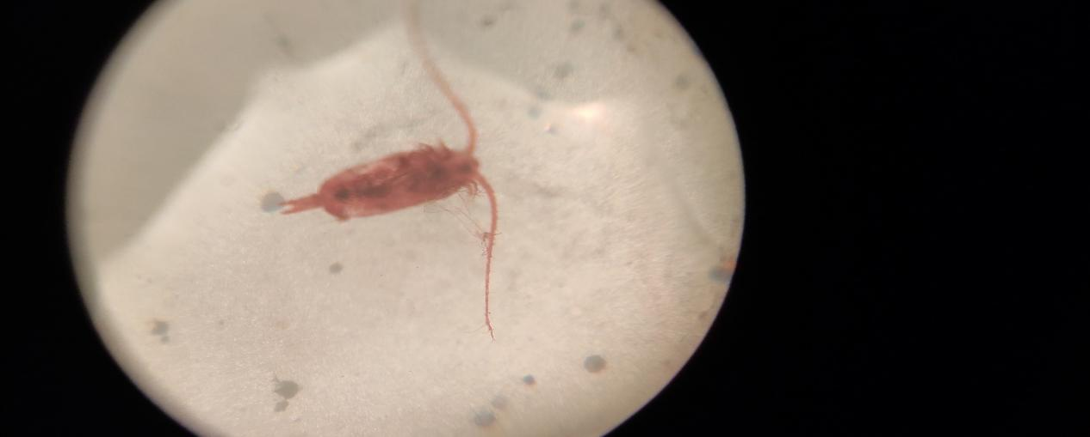

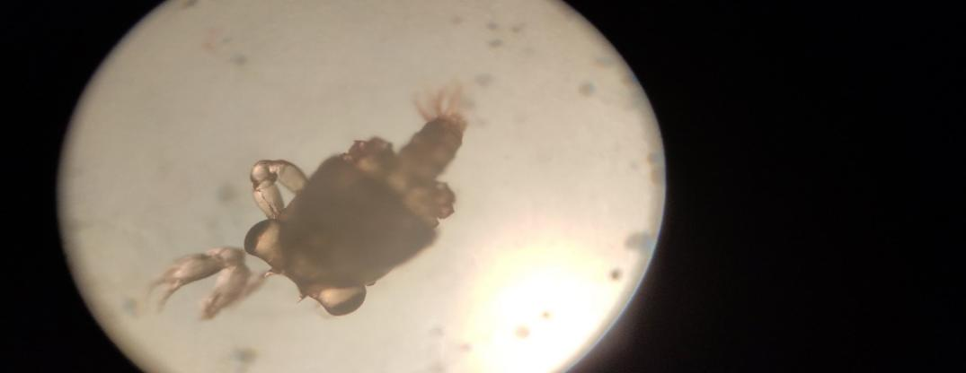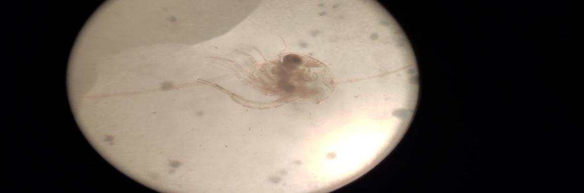

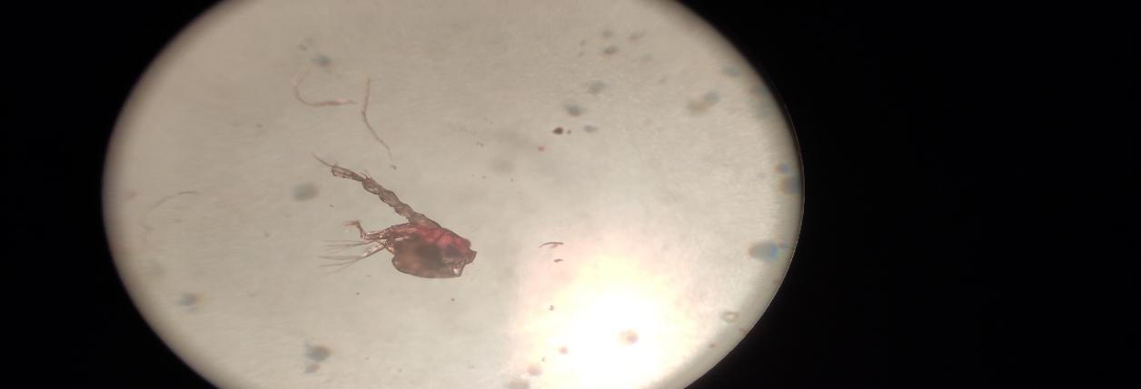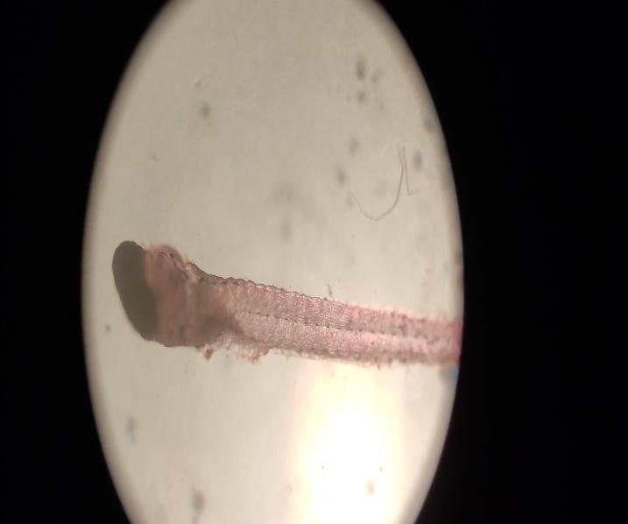

**Fig: Zooplankton species**

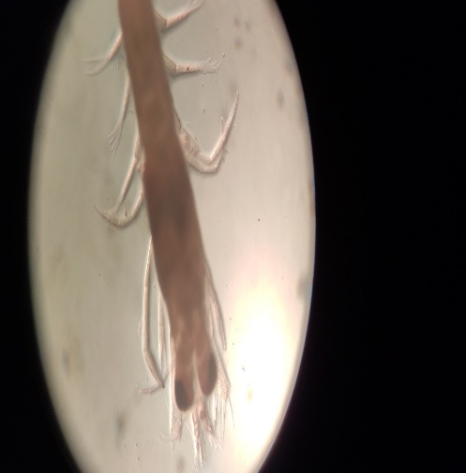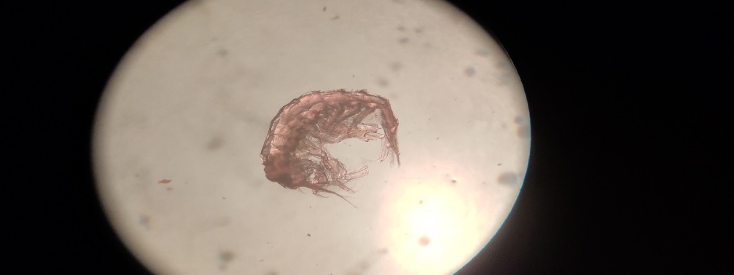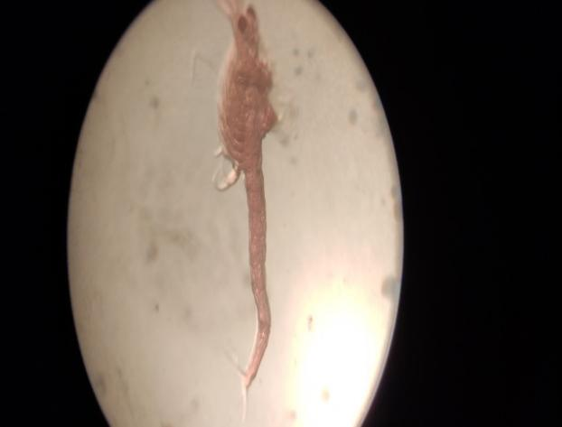

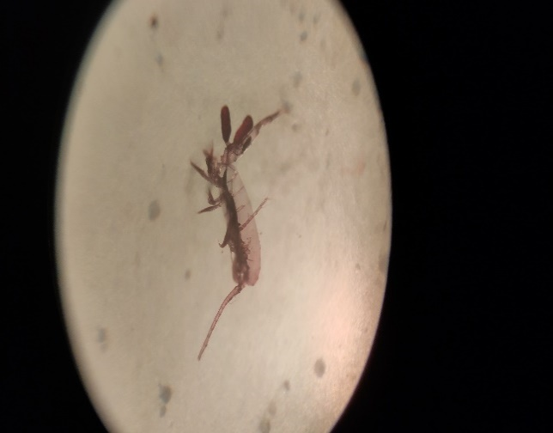

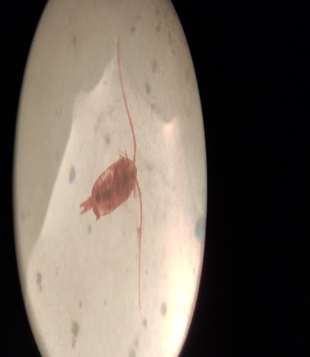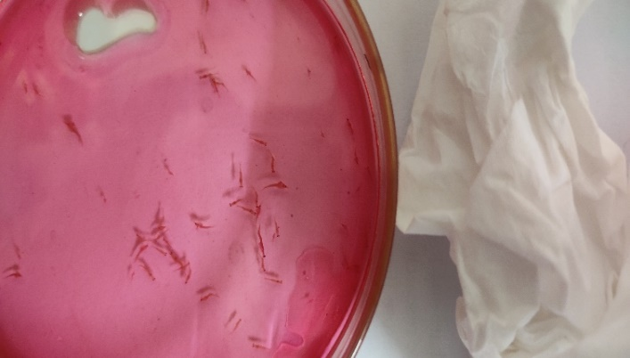

**Fig: Zooplankton species**

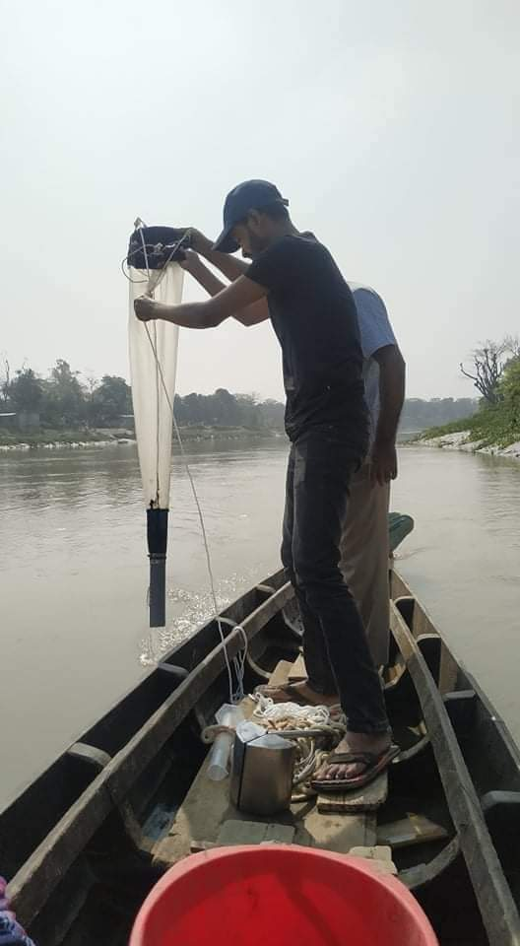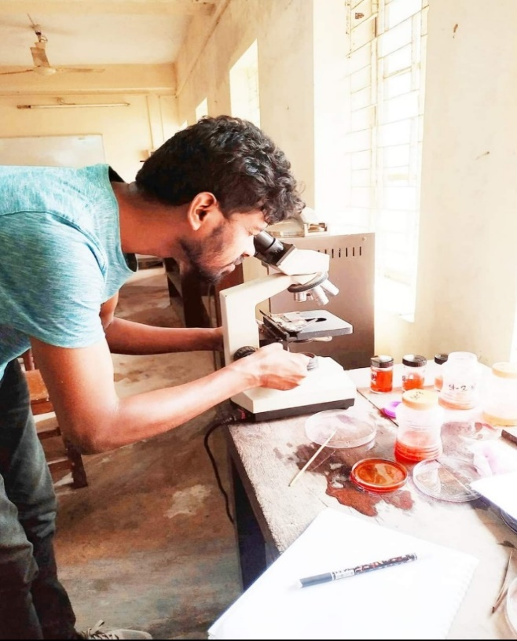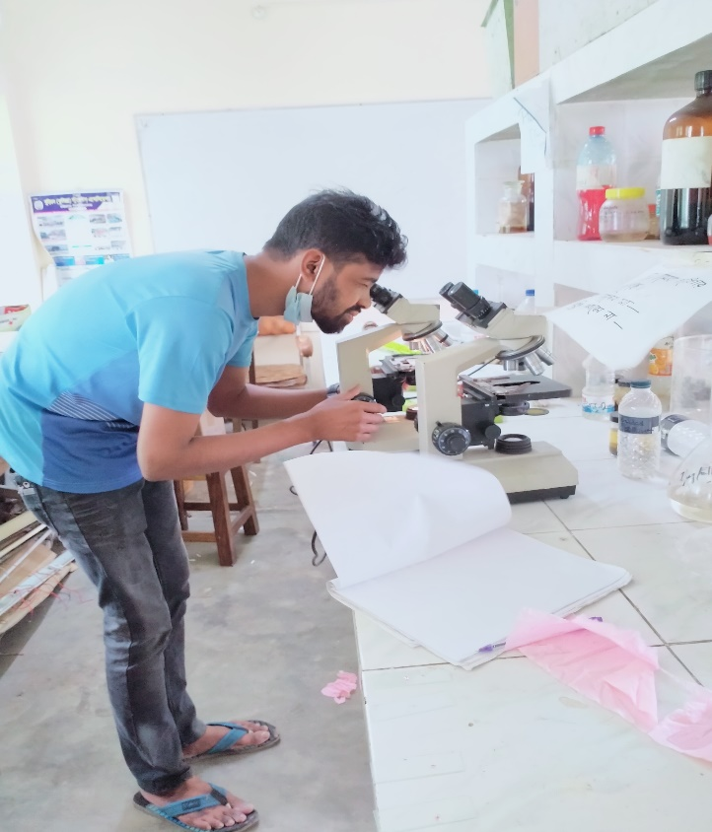 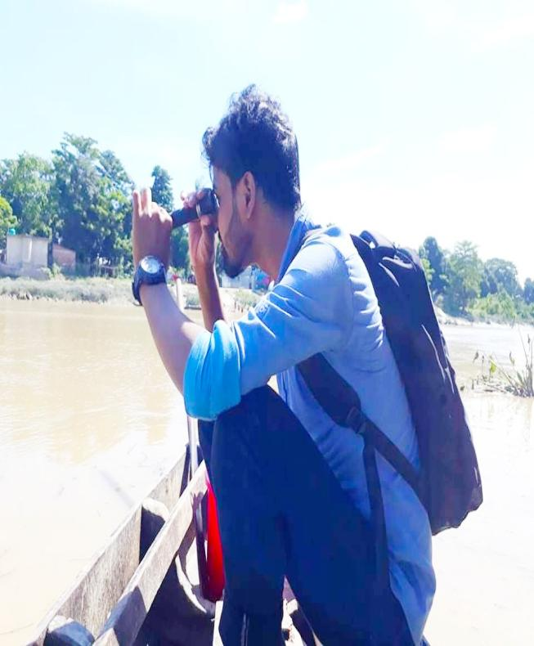  
 **Fig: Sampling & Lab Analysis**